# Help for Onscreen Marking

The Onscreen marking tool consists of a marking-, commenting-, and rubric toolset that will assist with the marking of assignments. When one use these tools in conjunction with a workflow tool of some kind one can almost achieve a paperless assignment system.

The current onscreen marking tool will save the marks into the file name of the assignment upon finalization. If the workflow system used could strip the score from this file name one can also automate the uploading of marks to a class list or marks capturing system.

At Unisa we use a routing program taking care of all this but being a propriety system the router could not be made available as part of the solution at this stage.

### Marking Tool Installation

**ONLY assignments in PDF format can be marked with the onscreen marking tool.**

**Prerequisite: ADOBE Professional 9 or ADOBE 10 must be installed on your computer**

### Which tool should you use and when?

**How do you know which one to choose?**

1. If you mark with ticks and you want the computer to add them up for you to get to a total percentage, just use the Marking Tool that opens up with your Pdf assignment file. Select the Tick and assign a number of marks for each tick.  For example, each tick equals one mark and you add them up to get the total.
2. If you mark with set points per question – for example, 11 / 25 marks for Question 1 -- you would want to use the Marking Tool with the circle around N. In this way, you can assign a number value to a question or part of a question. For example, you put 11 and it will put 11 in a small circle. In this example, you can still use a tick symbol to show that you were there, that you read the question, etc, but use the inverted tick or carat (or use the regular tick with 0 marks).

With options 1 and 2 above, you can add other marks from the Adobe toolset – circle the offending grammar structure; put a block around the paragraph that needs to be moved, etc. You can also add comments by using the Commenting tool, but these comments are not involved with calculating the marks.

1. If you are used to using a rubric for marking, you can use the Commenting tool and assign a score to each comment. This can be used with the ticks for additional marks, but remember that all marks will be calculated together.

All of the points for options 1, 2 and 3 will be added up automatically by the program.

1. If you want to design a fool-proof system where each comment is assigned a mark, then you create a more-complicated rubric using the Rubric tool. This Rubric tool, however, can NOT be used in conjunction with any other option. This tool is a bit complicated and you may need additional training.

# The marking tools

The onscreen marking tool comprises:

• A Marking Tool

• A Commenting Tool

• An Assignment Rubric

Each of these solution components is described in detail below.

Operating functionality and interaction between the three tools are built in, but each component could function on its own as well.

### Marking Tool Bar

C:\DOCUME~1\JMOLLER\LOCALS~1\Temp\msohtmlclip1\01\clip_image001.png

When the marking tool is installed, the above toolbox will open approximately 5 to 10 seconds after you have opened a PDF document and install itself in the toolbar ribbon at the top of the page.

The icon functions from left to right:

1. The half a mark tick. To give only ½ a mark per tick. Select this icon by clicking on it. Now click on the assignment wherever you want to give ½ a mark.
2. The variable score tick. Every time when you select this option you must assign a value to the mark. Thereafter every time you click on the document that number of marks will be allocated.
3. The inverted tick is to indicate that you have read the portion but it carries a zero mark value.
4. The cross to indicate something as wrong. Zero value.
5. The arrow icon cancels the current tick in use before selecting a following tick,. Or use it to change the mark value of the second icon on the toolbar.
6. The “N” icon allows you to give an impression score to a section. Typically you will use this with the inverted tick. For example, tick to indicate that you have read a section, the click on the N and enter a mark. You can also name the section you have mark. It can be Section #, Question #, Q#, Page #, etc. The naming of the section or portion is optional and may be left empty.
7. The “C” icon is for calculations, it adds all the marks allocated.
8. The C icon can be used in collaboration with the commenting tool. When you have comments you would like to add to a section or answer with an appropriate score you can use the “C” tool.

### Commenting Tool

Opened from an icon on the desktop

C:\DOCUME~1\JMOLLER\LOCALS~1\Temp\msohtmlclip1\01\clip_image001.png

**Populating the commenting tool with comments**

1. Open the commenting tool (It will open and display as a vertical blue bar on the left-hand side of the screen.)
2. To access the commenting tool, click on the blue bar. The commenting page will open.
3. Enter the Course code, assignment number and the assignment total in the relevant text boxes.
4. Add elements. These might be Question #, or Section #, or Page #. Any way you choose to distinguish between different parts of the assignment.
5. Click on the Green plus sign to add comments for a particular section or element.
6. During the adding of different comments for different sections you can indicate a mark value for each remark.

Comments can be personalized once pasted into an assignment.

The completed comment tool, with comments and/or scores, can be distributed amongst markers. The C icon is used to enter that allocated marks.

**Using the commenting tool**

The commenting tool can

a) add predefined comments to an assignment or

b) add a comment with a deserving score to an assignment

**Adding comments to an assignment**

Select the appropriate comment by clicking on it. A red line appears around the comment, indicating its selection status.

1. Click on the standard Adobe Sticky Note icon in the toolbar ribbon of Adobe and click where you want to add a comment.

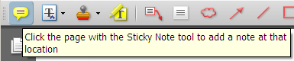

1. Right click on the speech bubble and select the paste option to stick the comment in the speech bubble. Remember you may customize and edit the comment further if you wish too.

**Adding comments and a score to an assignment**

1. To select the appropriate comment, click on the icon to the right of the comment (it looking like a stack of papers below the score box).

C:\DOCUME~1\JMOLLER\LOCALS~1\Temp\msohtmlclip1\01\clip_image001.png

1. Select the C icon and click on the assignment where you want the score and comment to be inserted.

### Rubric Tool

The rubric tool is a complex tool requiring detail in execution and prior setting up. I will also strongly recommend that the user create a folder on the PC for the purpose of saving commenting files with extension XML and rubrics with extension PDF. Eg. A folder called “Comments&Rubrics” or “C&R” is ideal.

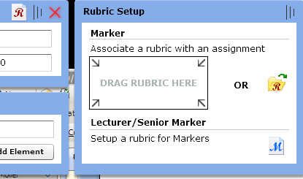

**Create and associate a rubric with the course**

1. Open the commenting tool (It will open and display as a vertical blue bar on the left-hand side of the screen.) Click on the blue line to reveal the tool.
2. Enter the course code, assignment number and total for the assignment.

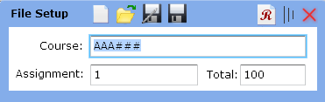

1. Click on the <Save as> icon on the top line (it looks like a computer disk) to save the file somewhere where you will find it easily. As suggested earlier a folder called Comments&Rubrics is ideal. A XML file will be saved with a name equal to the name you entered into the box for the course name with an underscore and the assignment number.

Eg. AAA###\_1.xml

1. Click the red “R” icon on the top right-hand corner of the commenting tool.
2. The Rubric Setup box will open. Click on the blue “M” icon.
3. Click on the save option of the dialogue box that will open. Here it is not important where the file is saved as it is a temporary file.
4. Minimize the commenting tool by clicking on the three vertical lines between the red cross and red R. You should see a window called “UNISA ASSIGNMENT RUBRIC”\*
5. Complete the fields for Course code and assignment number.
6. Draw up a rubric. A specific section on how to draw up a Rubric and Marking with a Rubric will explain everything you should know to complete the rubric.
7. Scroll down to the last page of the rubric when all the fields, elements etc are completed.
8. Click on the Finalize Rubric for Marking button on the last page of the rubric.

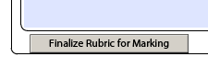

1. Click on the Computer Disk to save the finalized rubric somewhere where you can find it easily. A good place is once again the Comments&Rubrics folder we suggested earlier. The file name will once again be the course code, underscore assignment number.

eg. AAA###\_1.pdf

1. Before associating the rubric file, you need to create a duplicate file and name it:

coursecode\_rubric\_backup

eg. AAA###\_1\_Rubric\_backup.pdf

1. After a rubric is **created and saved** it must be associated with the commenting tool. This is done by clicking the Red R on the yellow folder.

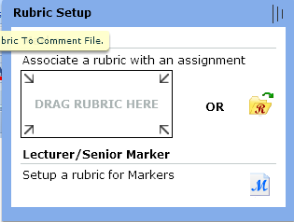

1. Browse for your saved rubric AAA###\_1.pdf. Double click the file or associate rubric with a commenting file by dragging it to the appropriate box. When done successfully the Red R will turn green.
2. Save the Comments file again after a Rubric was associated with it. In future you can then simply open the comment.xml file and the rubric will automatically be associated with that specific comment file.

**Draw up a rubric**

The previous set of instructions did not explain how the rubric itself is to be completed. This is an academic exercise requiring a high level of understanding of the nature of the module as well as the learning outcomes required.

**Rubric Logical Explanation**

The rubric makes use of 3 levels of logically related information, namely: ELEMENTS, CRITERIA and COMMENTS.

1 ASSIGNMENT RUBRIC can contain 1 to many ELEMENTS

1 ELEMENT can contain 1 to many CRITERIAS

1 CRITERIA can contain 1 to many COMMENTS

Each ELEMENT has a TOTAL field

Each COMMENT has a MARK field

Each one of these 3 levels makes use of alternating colours to easily distinguish what section you are on:

ELEMENT: light green and light red

CRITERIA: light grey and dark grey

COMMENTS: light orange and dark orange

ADD and REMOVE buttons are provided to build your RUBRIC ASSIGNEMENT.

The figure below shows all the buttons that will help build an ASSIGNMENT RUBRIC, with ELEMENTS, CRITERIAS and COMMENTS. The MARK and TOTAL fields are also indicated.

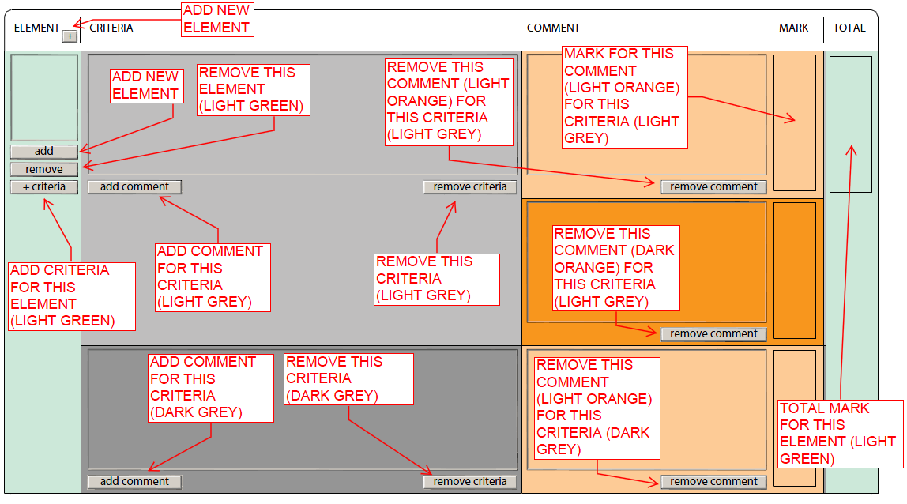

Figure Rubric Buttons and Fields

The following figure below shows a filled in Rubric with text filled in that explains the relationship between an ELEMENT and its CRITERIAS and COMMENTS.

The Lecturer will setup the rubric using the add and remove buttons and adding the necessary text. The LECTURER must fill in the ELEMENT, CRITERIA and TOTAL fields.

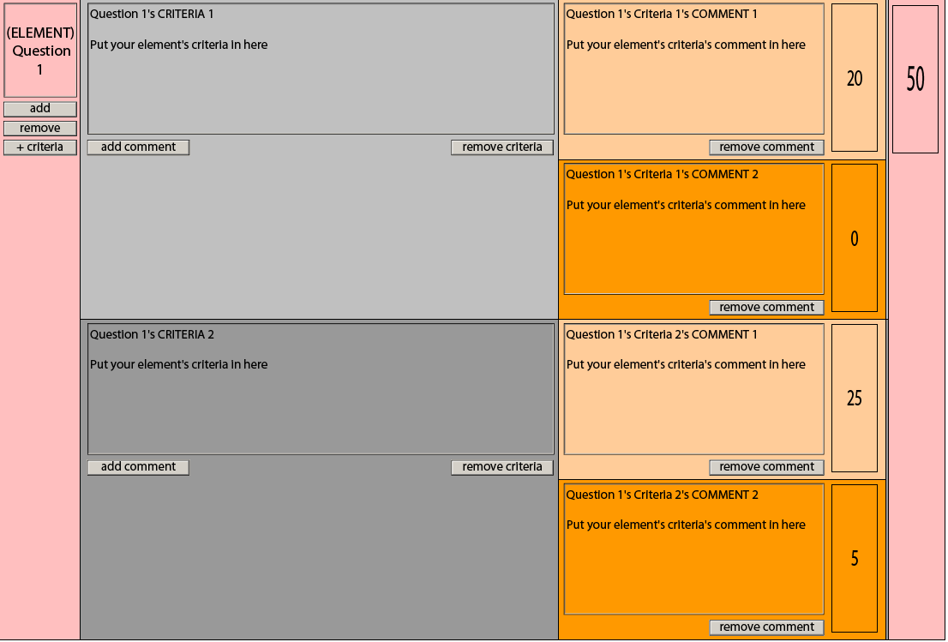

The figure below shows a filled in Rubric ready for a marker.

The marker can edit/modify COMMENTS and MARK fields setup/advised by the lecturer.

Should the marker wish to add his own COMMENTS, he/she can simply click the ADD COMMENT button.

By clicking the KEEP checkbox under a COMMENT box, allocates the associated COMMENT and MARK to the final Assignment Rubric destined for the Student.

Each CRITERION must have at least 1 KEEP check box checked.

If a KEEP checkbox is checked, it’s associated COMMENT and MARK fields must be filled in.

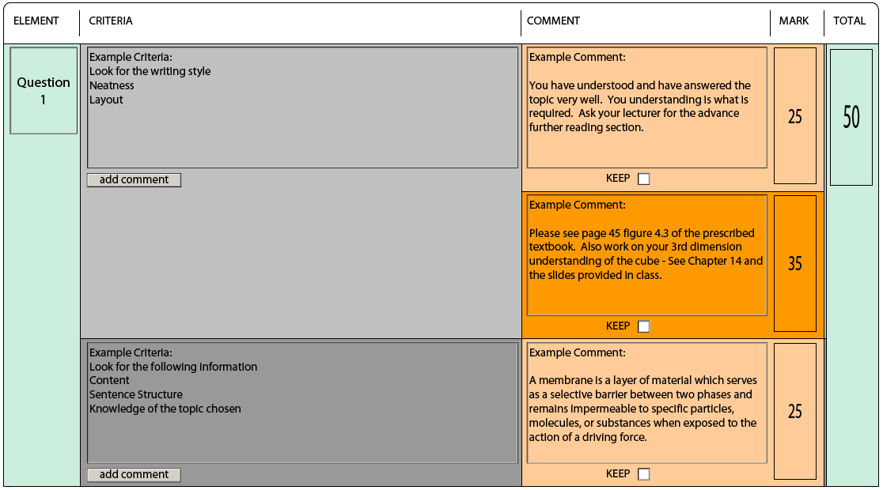

Rubric in MARKER MODE

The figure below shows a filled in Rubric ready for student presentation.

All fields are non-editable and no buttons are visible. This is a read only report for the student.

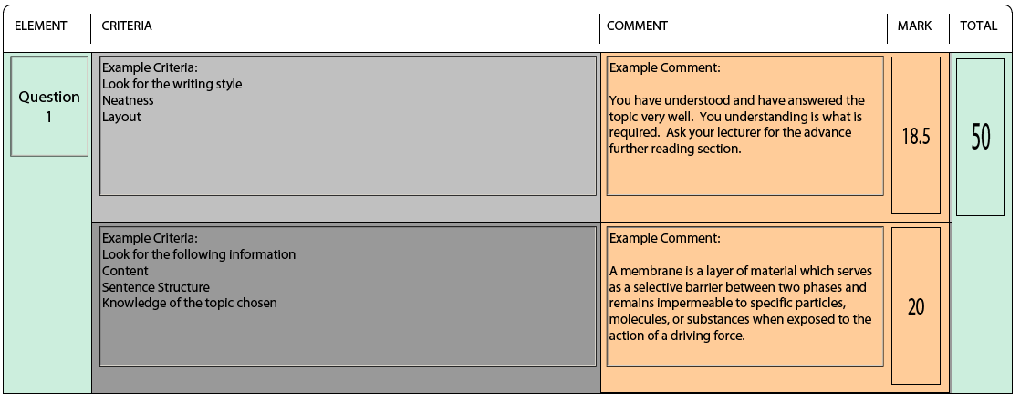

The figure below shows a filled Rubric header.

The LECTURER must fill in the Course Code and Assignment No. fields.

The MARKER must fill in the Student Number and Marker fields.

The Date Marked and Rubric Created (not currently visible) fields are automatically populated.

The Progress section shows who has interacted with the Rubric and what status the rubric is in.

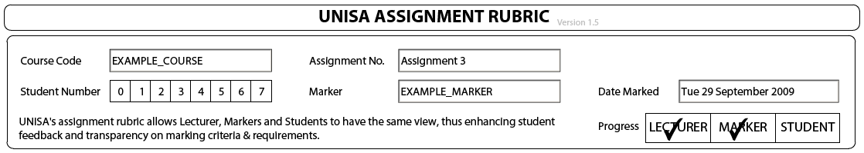

The figure below shows a filled in Rubric’s result footer.

The General Comments is a free text / communication section for the Lecturer / Marker.

The RESULT fields are automatically calculated, based on the sum of the ELEMENT TOTALS and number of COMMENTS who have their KEEP checkboxes checked.

The PERCENTAGE is automatically calculated, based on the result fields.

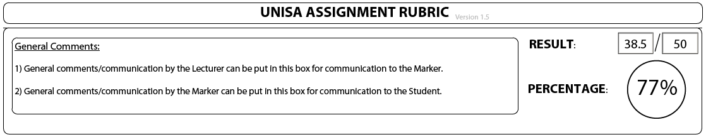

* **References to Unisa in the Rubric should be removed when you customize its use for your organisation.**

**Marking with a rubric**

Assuming the rubric was saved, associated and opened once the assignment is ready for marking. Use a double monitor system or Alt TAB between the two windows on the screen or open both windows on the same screen next to each other.

Marking:

1. Open the commenting tool (It will open and display as a vertical blue bar on the left-hand side of the screen.) Click on the blue line to reveal the tool.
2. Use the yellow folder option and open the relevant XML file.

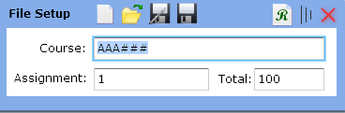

1. Because you already associated a rubric with this commenting tool the R will be green.
2. Close the comments tool by clicking the three vertical lines between the red cross and the green R.
3. Open the PDF assignment file. Normally from the desktop of the router tool.
4. Click on the Open Rubric button at the bottom left corner of the first PDF page of the opened assignment.
5. C:\DOCUME~1\JMOLLER\LOCALS~1\Temp\msohtmlclip1\01\clip_image001.pngThe rubric page will open with the browser. Note it will work even if you are not connected. The PDF rubric must open in the browser so that the Adobe professional marking tools can still be active on the assignment PDF document.
6. Enter the student number, and marker name in the spaces provided.
7. Select the appropriate comments by clicking in the check boxes.
8. When done click on the finalize rubric for Student button on rubric tool itself.

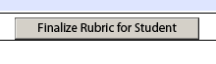

1. Click on <File> and then <Save>.
2. Go back to the Assignment and make at least one tick or inverted tick on a page.
3. Select the Calculator tool and say yes to the question that will pop up asking whether the assignment has a rubric attached.
4. Click on the Finalize button on the last page of the assignment, and answer the questions in the pop-up box. Normally a Yes are required.

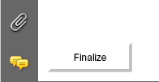

1. Click on <File> and then <Save> and exit document.